**LAB 12 Procedures Sec B component 2**

**2147241-ANAGHA R**

1. Use database “university”

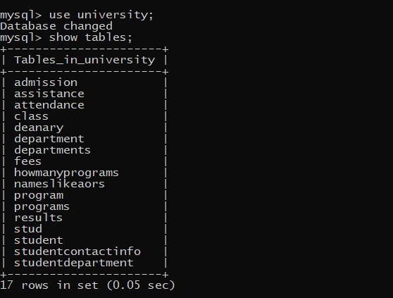

1. Use table “admission”

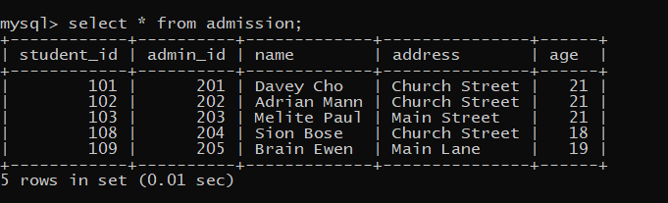

1. Procedure

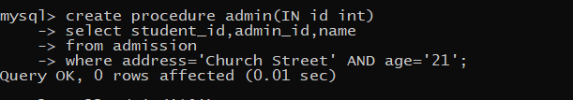

1. Calling the procedure “admin”

